

Rattib Mashawerak
A project submitted
in partial fulfillment of the requirements for the degree of
Bachelor of Management Information Systems

By team members:

Leader: Fatima Ali Abdullah Alwael | 222423328
Battol Hashem Alahmed | 222430663
Norah Abdullah Alrwayshid | 222435958
Manar Ahmad Al bohassan | 222437744
Rayhanah Ahmed Alhulaymi | 222404219

Supervised by
Dr. Osamah Mohammed ALomair

May 2025

ACKNOWLEDGEMENT
We would like to express our sincere gratitude to Dr. Osamah Mohammed ALomair for his valuable guidance, encouragement, and continuous support throughout this project. His insights and expertise were essential to the successful completion of this work.
Special thanks to our Management Information Systems Department, School of Business, King Faisal University for providing the resources needed and the environment that helped us carry out this project efficiently.
We also wish to thank ourselves as collaborative, dedicated, and hard-working teammates, which made this project a rewarding experience.

UNDERTAKING
This is to declare that the project entitled “Rattib Mashawerak” is an original work done by undersigned, in partial fulfillment of the requirements for the degree of “Bachelors of Business Administration” at Management Information Systems Department, School of Business, King Faisal University.
Further, it is hereby declared that the entire project work including the analysis, design and system development has been accomplished by the undersigned. Moreover, this project has not been submitted to any other college or university.


Leader: Fatima Ali Abdullah Alwael – 222423328


Battol Hashem Alahmed – 222430663  Norah Abdullah Alruwayshid – 222435958





Manar Ahmad Al bohassan – 222437744  Rayhanah Ahmed Alhulaymi – 222404219

ABSTRACT
In a world were organizing time and completing tasks or trips efficiently has become a necessity. "Rattib Mashawerak" helps you organize your daily trips or tasks based on your geographical location, ensuring that you benefit from most of your time with the least effort.
Our project "Rattib Mashawerak" suggests the shortest optimal path to completing daily tasks and activities by determining the geographical location as it arranges the trip logically based on its temporal and geographical proximity. It suggests a single-lane route to complete the tasks nearest to the farthest, considering market closing times, working hours and congestion; if the road is crowded, it suggests another smoother route. When you approach a specific location, the application sends you an alert reminding you of the tasks or trips based on the proximity to the location associated with that place. It also helps you plan the best route to complete all your tasks in the shortest possible time. Furthermore, "Rattib Mashawerak" also provides incentive rewards after completing a certain percentage of trips or tasks.

TABLE OF CONTENTS

- Preliminary Investigation 1
  - Introduction 1
  - Problem statement 1
  - Solution 1
  - Scope of Project 2
    - What is Included in the System 2
    - What the System Might Not Cover 2
  - Feasibility Study 3
    - Operational Feasibility 3
    - Technical Feasibility 4
    - Economic Feasibility 6
  - Functional Requirements 6
  - List of staff functions 7
  - Data Collection Techniques 8
  - System Requirements 16
  - Technologies 17
  - Project Timeline 17
- System Analysis 18
  - Overview 18
  - Context Diagram 18
  - Functional Decomposition Diagram 19
  - Data Flow Diagram 20
- System Design 21
  - Overview 21
  - Input and Output Forms Design 21
  - Prototype Design 22
  - Entity Relationship Diagram 30
  - Normalization 31
  - Logical Database Design 32
  - Physical Database Design 33
- Development 37
  - Overview 37
  - Tools/ technologies selected for implementation 37
  - Navigation design 37
  - User interface design 39
  - Database connectivity 39
- Testing and Conversion 40
  - Overview 40
  - Test plan 40
  - Unit testing 40
  - Integration testing 40
  - System testing 40
  - Conversion plan 38
- System Documentation 41
  - Overview 41
  - User manual 41
  - Technical support manuals 44
  - Online Help and FAQs 44
- Reference 47

LIST OF TABLES
Table 1.1 Hardware Requirements 5
Table 1.2 Software Requirements 5
Table 3 Input and Output Forms Design 21

LIST OF FIGURES
Figure 1.8.1 Responses 8
Figure 1.8.2 Responses 8
Figure 1.8.3 Responses 9
Figure 1.8.4 Responses 9
Figure 1.8.5 Responses 10
Figure 1.8.6 Responses 10
Figure 1.8.7 Responses 11
Figure 1.8.8 Responses 11
Figure 1.8.9 Responses 12
Figure 1.8.10 Responses 12
Figure 11 Responses 13
Figure 1.8.12 Responses 13
Figure 1.8.13 Responses 14
Figure 1.8.14 Responses 14
Figure 1.8.15 Responses 15
Figure 1.8.16 Responses 15
Figure 1.8.17 Responses 16

PRELIMINARY INVESTIGATION

Introduction
Many people struggle to manage their tasks or trips and plan the right time to do them effectively and efficiently. Our project addresses the need of an application that helps people organize their tasks or trips using AI and GIS API. Moreover, it provides incentive badges after completing a certain percentage of trips and tasks. Solving this problem supports people to focus on the important tasks or trips and finish them in the least possible time.

Problem statement
The problem that our project aims to solve revolves around the laziness of people to finish their trips because they are distracted between places and do not know the best available options and most of the time they forget what they want because of the multiple tasks around the clock and the lack of time; hence the need arises for a smart tool that organizes the path to save time and improve the transportation experience to save effort.

Solution
The solution provided by the application "Rattib Mashawerak" is to suggest the optimal path to complete daily tasks and activities by determining the geographical location; as it arranges the trip logically based on its temporal and geographical proximity; it suggests a single-lane route to complete the tasks closest to the farthest, taking into account market closing times, working hours and congestion; if the road is crowded, it suggests another smoother route.

Scope of Project
    - What is Included in the System

The application of "Rattib Mashawerak" aims to achieve several goals, including:
- Save time and effort for the user: This is done by completing trips in record time, which helps the user to facilitate his travel plan.
- Reduce traffic congestion: The application provides paths on the road that facilitate the traffic movement process and avoid congestion while completing trips.
- Speed of completion and productivity: The application helps users to schedule and plan their trips ideally to facilitate their completion without fatigue and boredom.
- Reduce costs: The application contributes as much as possible to reducing fuel consumption in the car.
- Motivate and encourage the user: The application aims to motivate users by appreciating their achievements through badges awarded at rates estimated for the number of trips completed by the user.
- The application aims to arrange trips according to their priority and not just based on their location.
- The application aims to organize trips of tourists and travelers within the city, allowing them to easily add the entertainment or historical places they visit and schedule them based on their location.
- Using AI to optimize trips or tasks based on the user’s location.

    - What the System Might Not Cover
Future improvements that may not be addressed, such as adding more features that don’t
support organizing trips or tasks.

Feasibility Study
Daily consultations have become complicated and difficult to organize for some individuals in society by making them vulnerable to many challenges and difficult situations. but not anymore with the “Rattib Mashawerak” application, which aims to provide plans and solutions to improve the mobility process of individuals by arranging daily trips efficiently and masterly through suggestions based on time, geographical location, traffic and completion time spent completing the journey.
Target group:
- Staff.
- Students.
- Families.

    - Operational Feasibility
- Chances are, will some users have difficulty working with the app and will they need training? Here you will find the most important solutions.
  - Add a video at the beginning of the page showing how to use the application and providing instructions and guides about the application.
  - Add a smart assistant that helps to answer the questions of users in case they are exposed to a problem, alert him or have difficulty searching for some icons.
  - Provide customer service to respond to technical emergency problems. 2- Usability of application:
  - Design an interface consisting of clear and understandable icons that allow easy navigation within the application to facilitate the use process for all age groups of users.
  - Access to multiple-choice features that contribute to supporting some groups in the community (audio description icon, font size, dark and day mode)
  - User Testing: Before the application is incorporated into the ground, we put a test of the application by performing a performance experiment on the eye of users to collect the necessary feedback to improve the experience of use.

    - Technical Feasibility
Database used: SQL.
Geographic information systems: Google Map, GIS API. Artificial intelligence.
- Economic risk: The excess cost that officials will charge from maintenance and updates that can be of high financial value, and operating expenses can be higher than revenue.
- Technical risks: Security problems that will attack the application such as hacker and security leaks or electronic attacks, weak response by technical support to problems of delay or disappearance of icons and other special problems as there was a large pressure of users, software errors that will affect the level of basic functions in the application.
- Operational risks: Slow response from technical support, delayed release of processing updates for the application
  - Operational solutions:
    - Perform frequent and continuous tests to ensure that there is appropriate security and security in the application.
    - Provide 24-hour active technical support that is fast and effective to receive user problems.
    - Enhance security and comply with international standards for maintaining user privacy.

      - Hardware
Table 1.1 provides an overview of the hardware and network requirements for the system designed. The table outlines the essential devices, processing capabilities, memory specifications, and network infrastructure necessary for optimal performance. A laptop serves as the primary device for executing the conversion process, powered by an Intel Core i5 processor. The system requires a minimum of 8 GB RAM to handle data-intensive operations efficiently. For connectivity, the setup includes a router supported by high-speed internet access, utilizing 5G to ensure seamless communication and data exchange.
Table 1.1 Hardware Requirements

Hardware The requirements

Devices Laptop

Processor 11th Gen Intel(R) Core i5

Memory 8GB RAM

Network infrastructure Router

Internet access 5G Wi-Fi

      - Software
Table 1.2 provides an overview of the software requirements for the project. It lists the essential software and tools needed to implement and operate the system. The table includes the following key components:
Table 1.2 Software Requirements

Software The requirements

Operating system Microsoft Windows, Android and Apple

Web server Apache, XAMPP

Programing languages Frontend: HTML5, CSS, JavaScript Backend: PHP
Database: MySQL
Code Editor: Visual Studio Code

Design tools Figma, Canva, Lucidchart, Draw.io

GPS and map software Google and Apple maps

    - Economic Feasibility
- Operational costs: Development costs: 20,000 SR per year
- Costs of Licensing:
  - Commercial Register + Chamber of Commerce = 5,500 SR per year
  - Stores:
    - Apple Store = 371 SR per year
    - Google Play = 93 SR per year
    - Microsoft = 371 SR per year
  - Marketing costs = 5,000 SR per year
  - Profit sharing costs = 100,000 SR
  - Technical support costs = 20,000 SR per year
- Foundation costs:
  - Coach costs = 20,000 SR
  - Legal license costs = 6,000 SR
  - Application design costs = 22,000 SR
  - Programming costs = 30,000 SR
  - The cost of the test is 3,000 SR

Functional Requirements
- User’s Secure Space: Users can create and sign into a personal, protected account.
- Planning User’s Day: Users can add, change, and remove daily tasks (work, errands, etc.) with details like location, time, and category.
- Smartest Way to Get Things Done: Users get the best route for tasks based on location, deadlines, and urgency, all laid out in a smart order.
- Avoiding Traffic Jams: Shows live traffic updates and gives suggestions for alternative faster routes if there's congestion.
- Friendly Nudges: Sends alerts when approaching the location of the next trip/task.
- Celebrating Wins: Tracks completed tasks or trips and gives rewards to users for finishing a certain percentage of their list.
- Everything Synced, Always There: The user's tasks and account info are saved securely and automatically updated across all your devices.

List of staff functions
- User:
  - Sign in/Sign up
  - Determine the places he visits several times.
  - Add, change, and remove daily tasks.
  - Arrange trips and tasks and specify places to visit.
  - Determines the times he wants to do his tasks or trips.
  - Add places to favorite.

Administrator:
  - Receives queries from users.
  - Updates to the application.
  - Solves problems for users and receive complaints.
  - Determines a percentage for badges.

Marketing Team:
  - Receives advertising needs from administrators.
  - Advertise for the application, its features, and more.

Data Collection Techniques

The results of Google Forms:

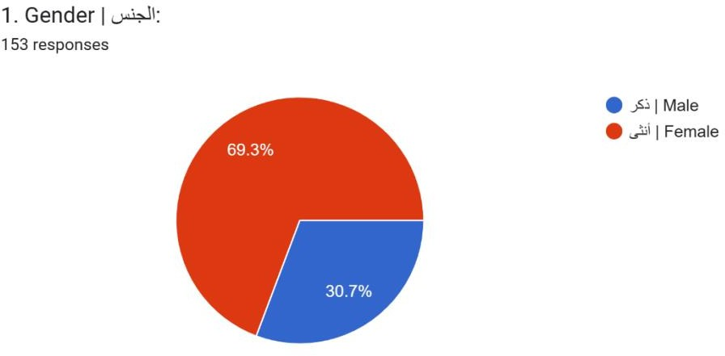

Figure 1.8.1 Responses

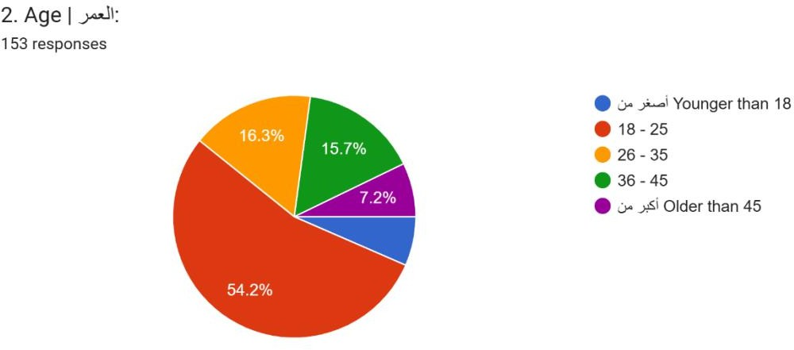

Figure 1.8.2 Responses

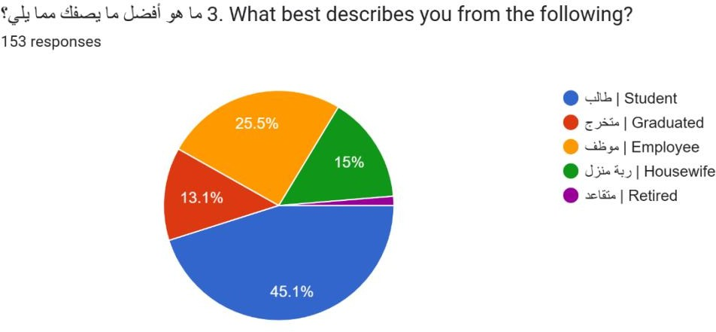

Figure 1.8.3 Responses

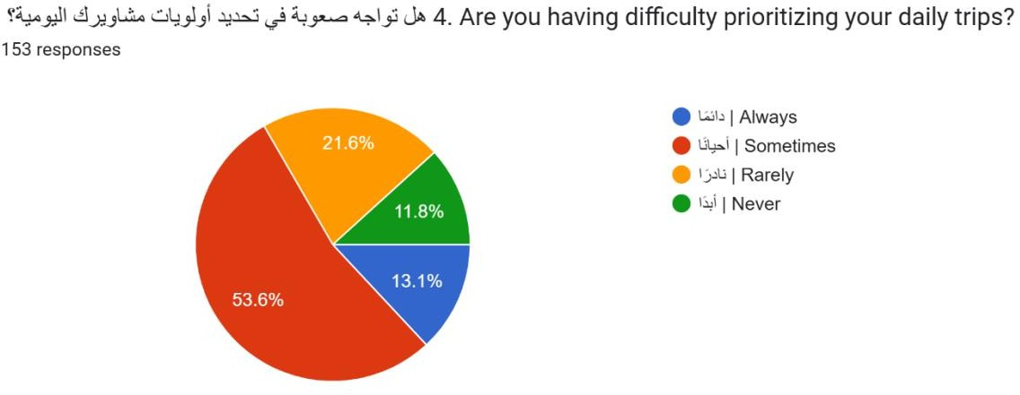

Figure 1.8.4 Responses

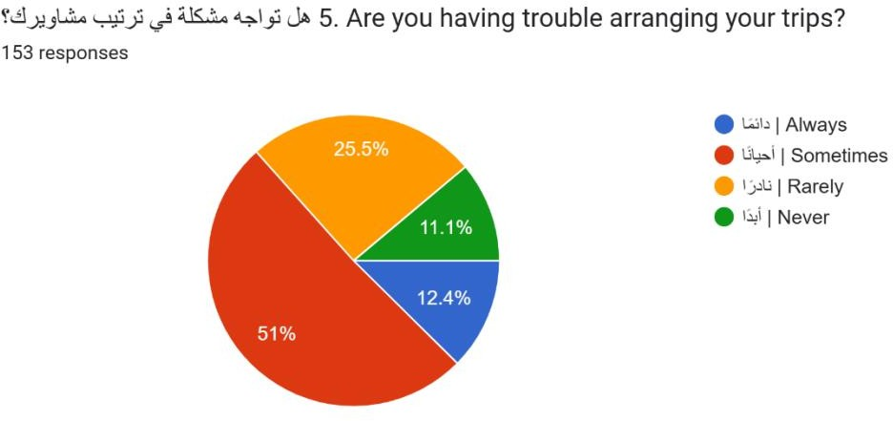

Figure 1.8.5 Responses
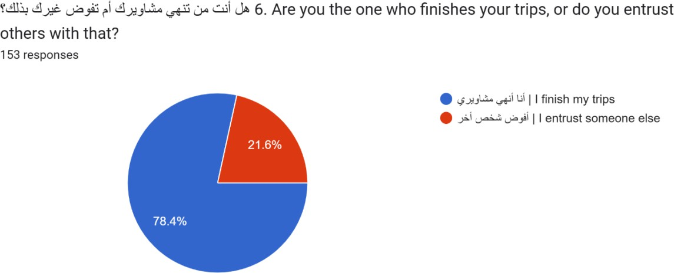

Figure 1.8.6 Responses

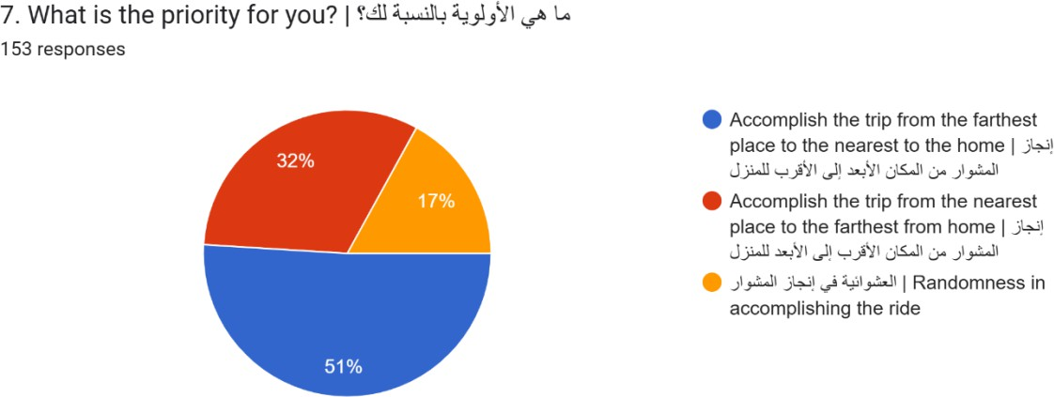

Figure 1.8.7 Responses
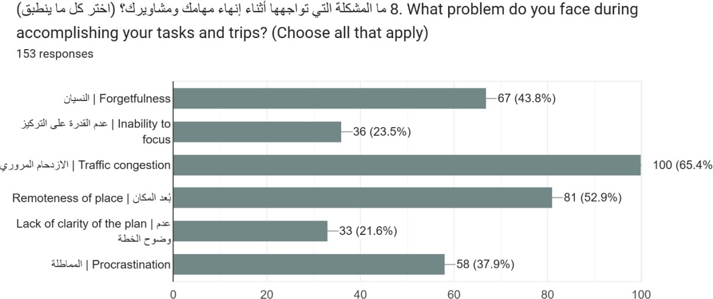

Figure 1.8.8 Responses

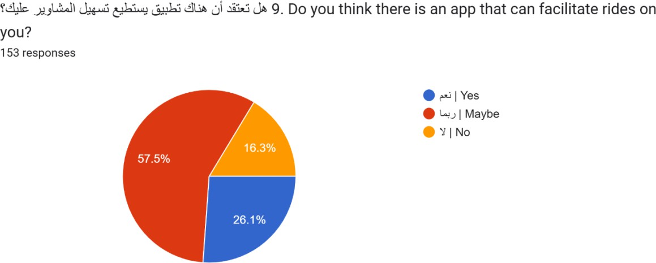

Figure 1.8.9 Responses
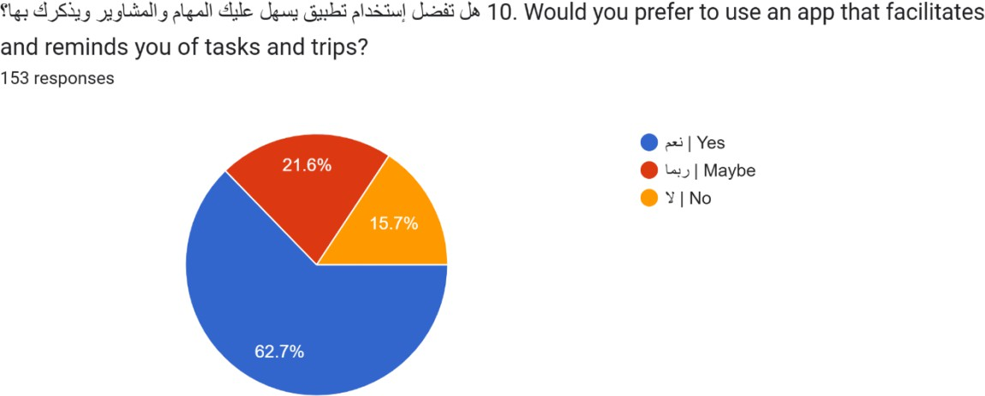

Figure 1.8.10 Responses

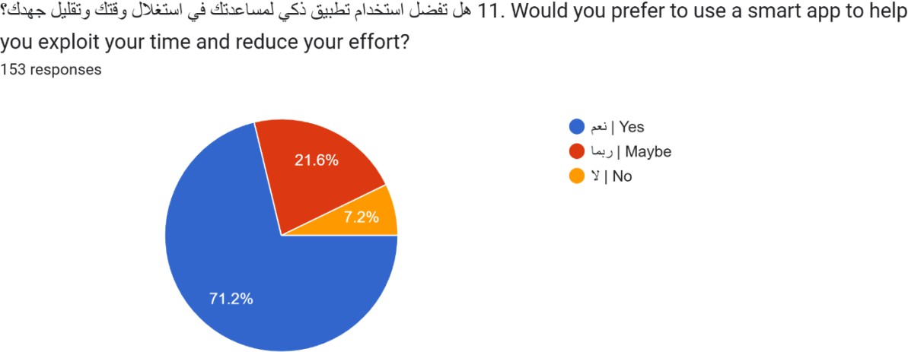

Figure 11 Responses
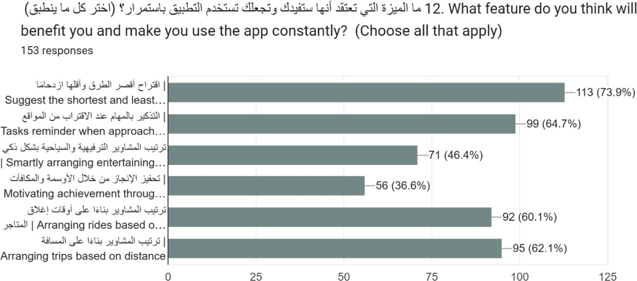

Figure 1.8.12 Responses

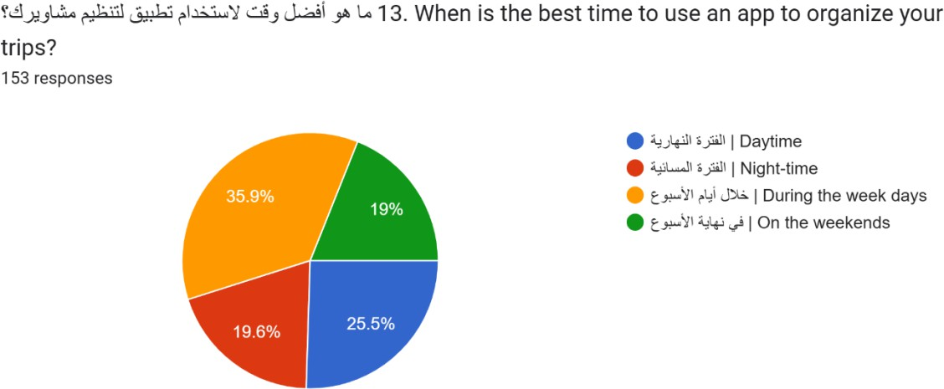

Figure 1.8.13 Responses
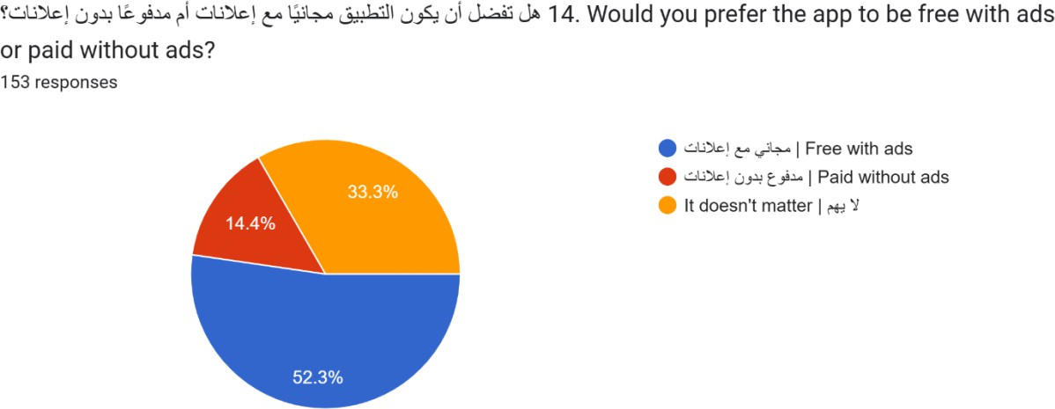

Figure 1.8.14 Responses

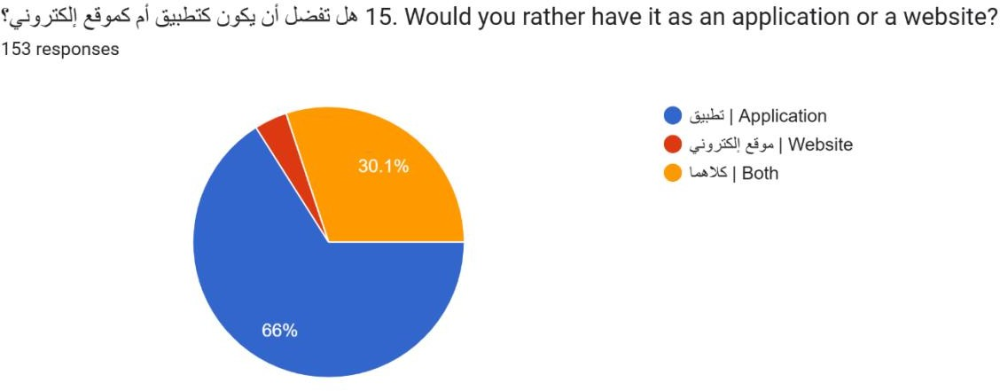

Figure 1.8.15 Responses
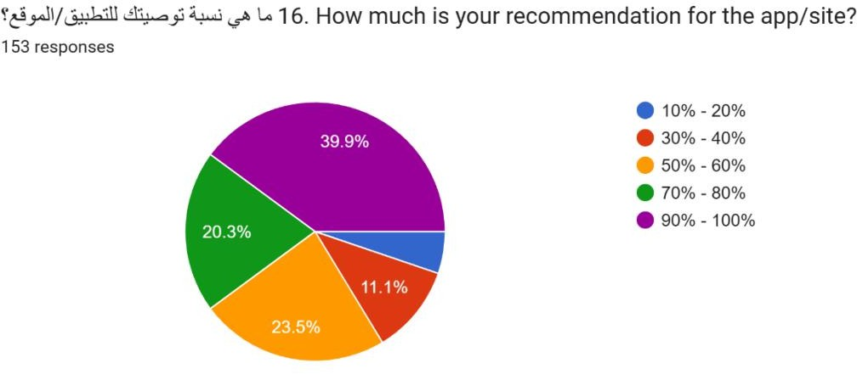

Figure 1.8.16 Responses

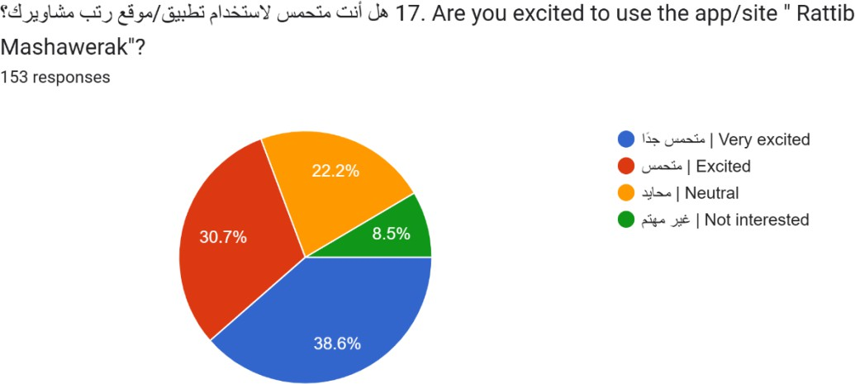

Figure 1.8.17 Responses

System Requirements
- Super Speedy: Route suggestions appear in under 3 seconds, and location alerts pop up in less than 1 second.
- Handles Anything: Works smoothly whether there are few or many users and tasks.
- Easy for Everyone: Simple and intuitive for all ages, with clear task lists and user- friendly maps.
- Always There for Users (Almost!): Reliable operation (99% uptime) with some features available even without internet.
- Super Secure: User personal and location data is encrypted, and their account is protected from unauthorized access.
- Works on Any System: Functions seamlessly on both Android and iOS devices.
- Easy to Keep Up to Date: Built in a way that makes updates, fixes, and improvements straightforward.

Technologies
- Planning:
  - Diagrams; Lucidchart, Draw.io

Analysis:
  - Microsoft Excel, Google Form.

Design:
  - Prototype (Figma).
  - Application Logo (Canva).
  - Database design: MySQL Workbench.

Development:
  - Google Maps API for location determining, GPS System, Open Source.

Application Testing:
  - Loadview.

Application Publish:
  - Google Play Console, Apple Store Connect.

Project Timeline

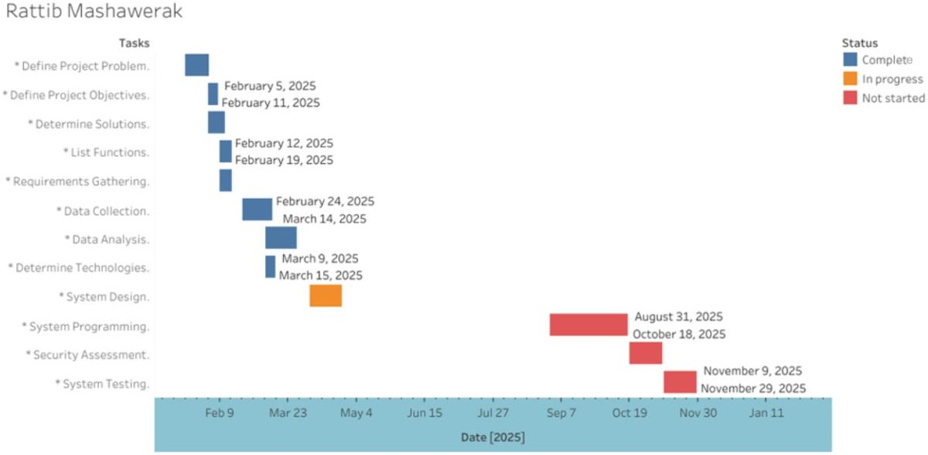

SYSTEM ANALYSIS

Overview
This chapter of the project provides a structured analysis of the system’s design and functionality. It starts with Context Diagram, which outlines the interactions between external entities and the system, giving a clear view of system boundaries and data exchange. Next, the Functional Decomposition Diagram breaks down the main system into smaller, manageable, well- defined sub-functions, offering clarity on each component’s role. Finally, Data Flow Diagram illustrates the internal flow of information through various processes and data stores, using level 0 and level 1 diagrams to visualize how data is processed within the system. These sections together contribute to a deeper understanding of the system’s architecture and data handling.

Context Diagram
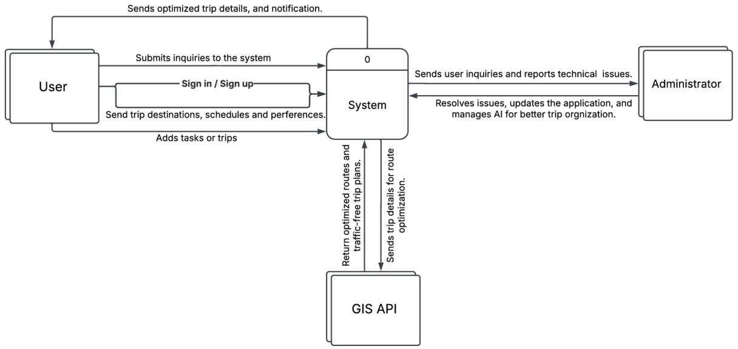

Functional Decomposition Diagram

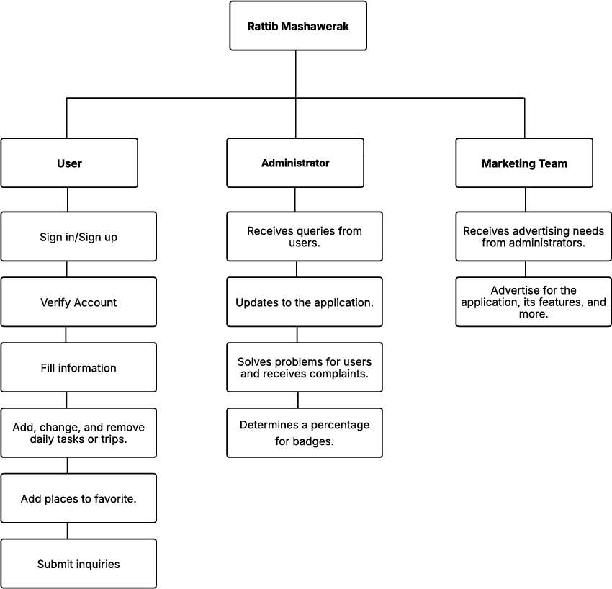

Data Flow Diagram
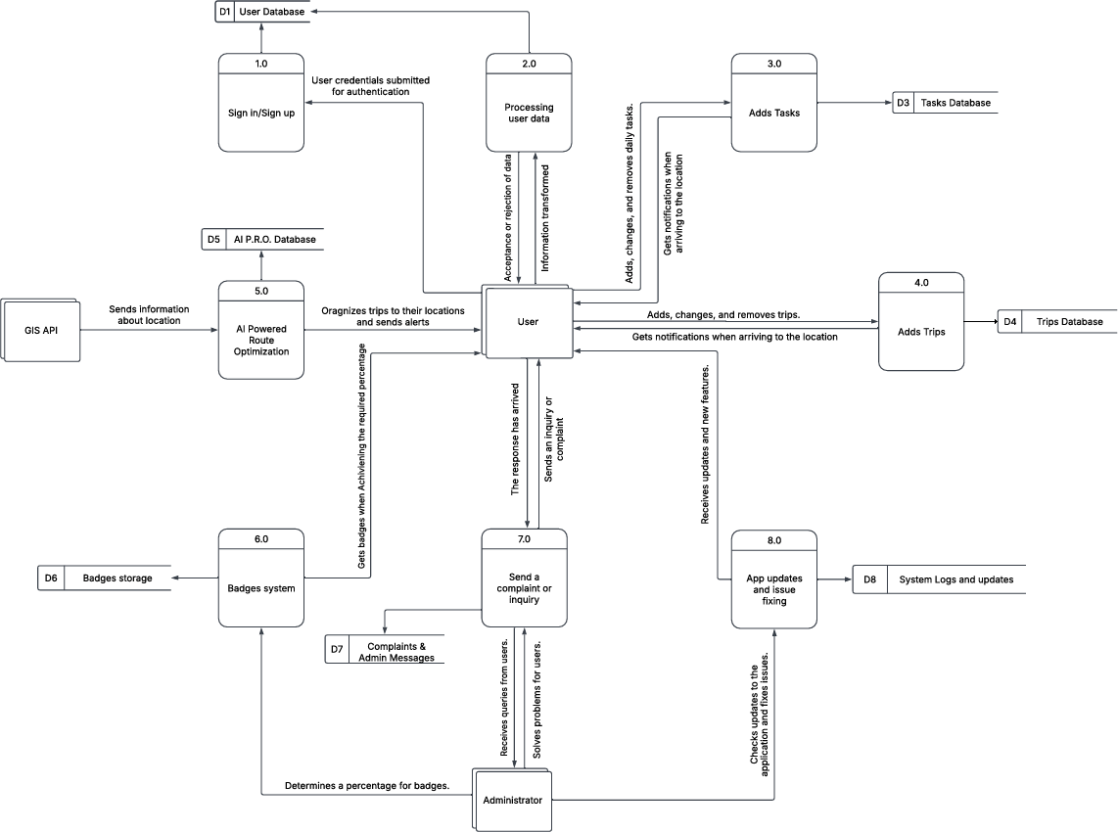

SYSTEM DESIGN

Overview
This chapter of the report focuses on the design and structure of the system’s data and user interface components. Firstly, The Input and Output Forms Design outlines how users interact with the system and how information is presented, ensuring usability and clarity to what is an input and an output. Second, Prototype Design provides a visual representation of the interface layout and functionality of the application, helping administrators visualize the system before development. Next, Entity Relationship (ER) Diagram defines the key entities and their relationships, forming the foundation for database structure. Furthermore, Normalization is applied to organize data efficiently, eliminating redundancy, and ensure data integrity. Finally, the Logical and Physical Database Designs translate the conceptual data model into a structured format, ready for implementation in the database system. All in all, this chapter guides the transformation from conceptual data planning to practical system development.

Input and Output Forms Design
Table 3 Input and Output Forms Design

Prototype number and name: | Input/output:
No.1 Sign in | Input
No.2 Sign up | Input
No.3 Home | Output
No.4 Map | Output
No.5 Address | Input & Output
No.6 Tasks | Input & Output
No.7 Trips | Input & Output
No.8 Settings | Output

Prototype Design
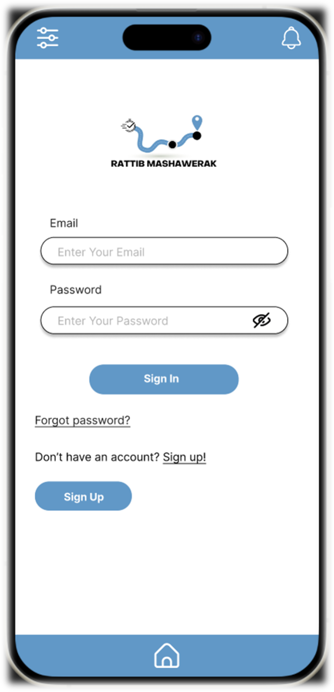

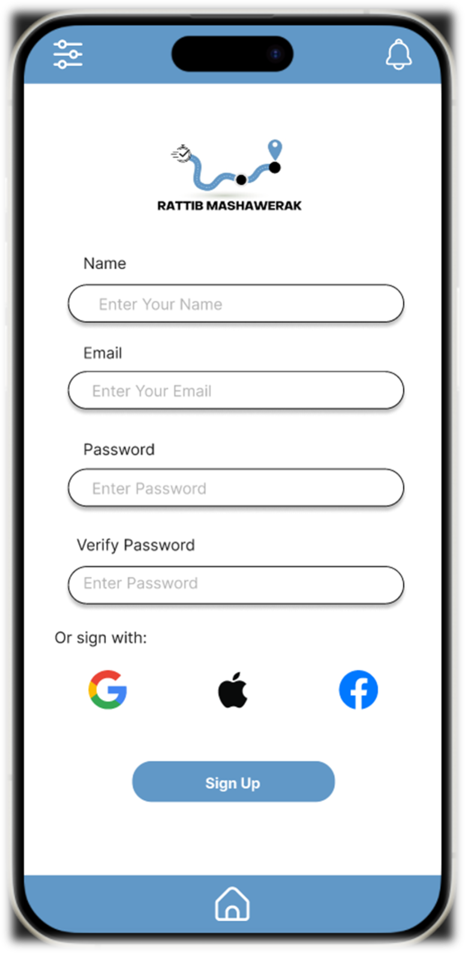

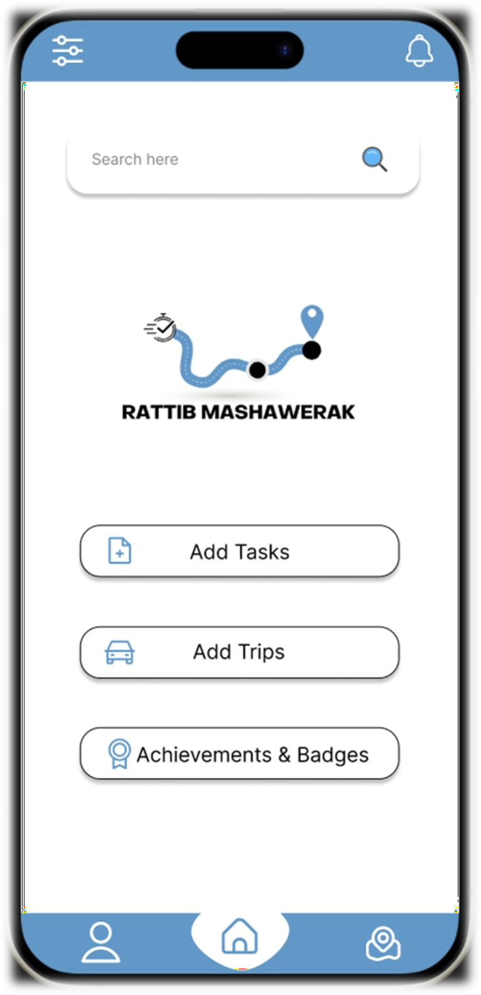

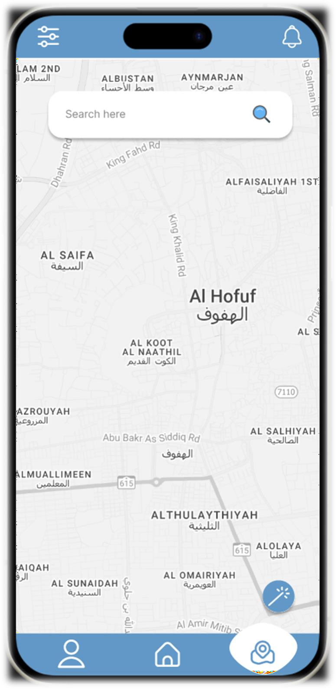

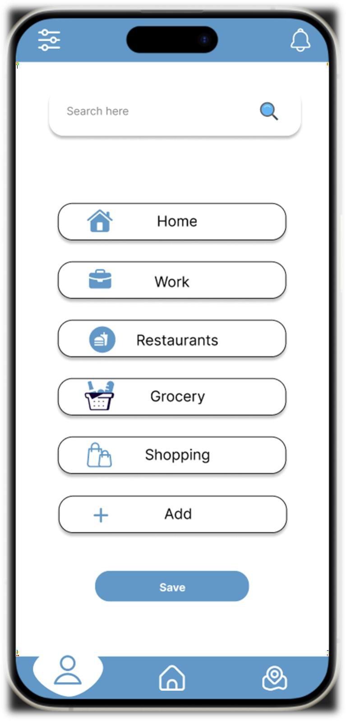

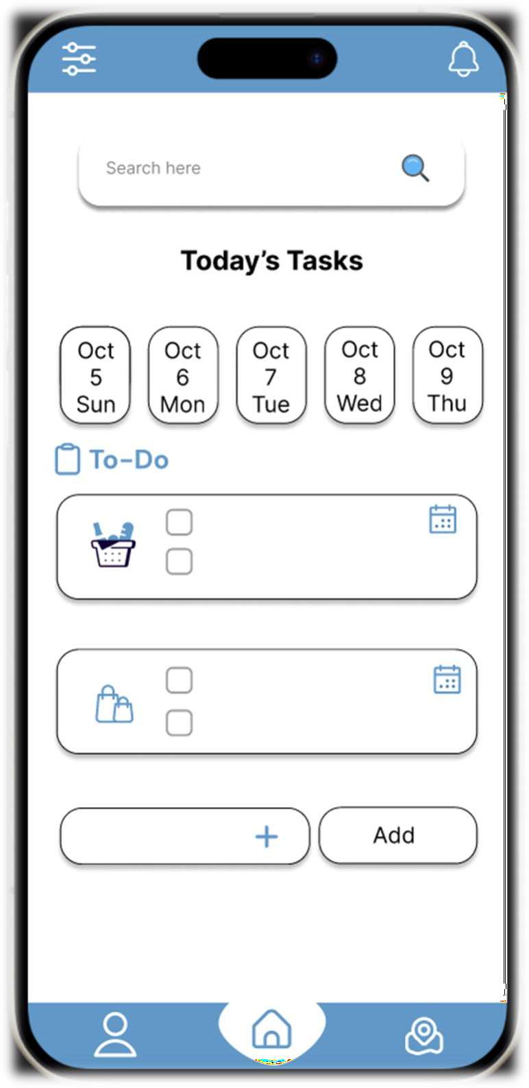

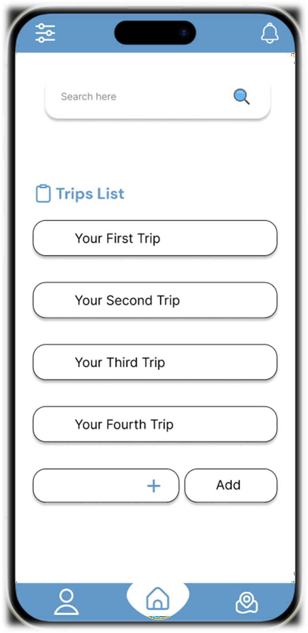

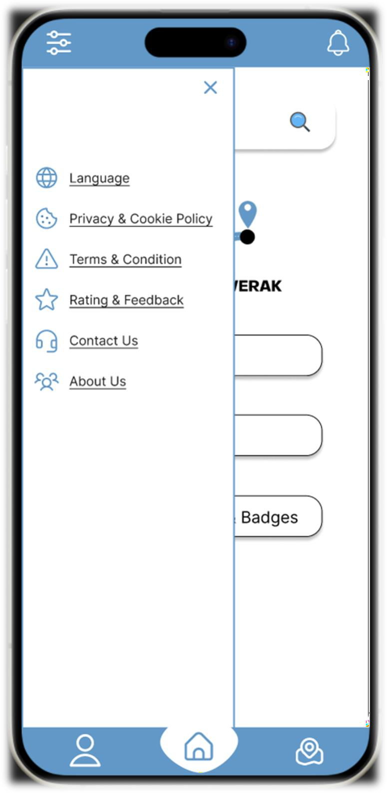

Entity Relationship Diagram
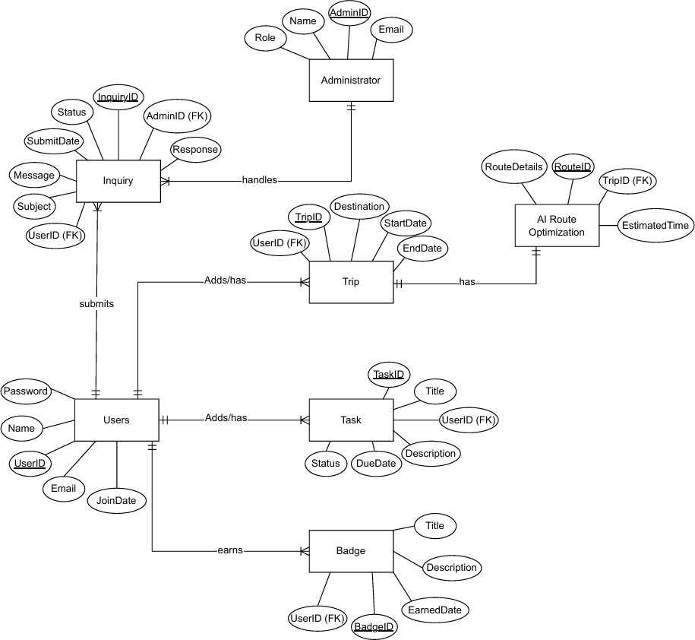

Normalization

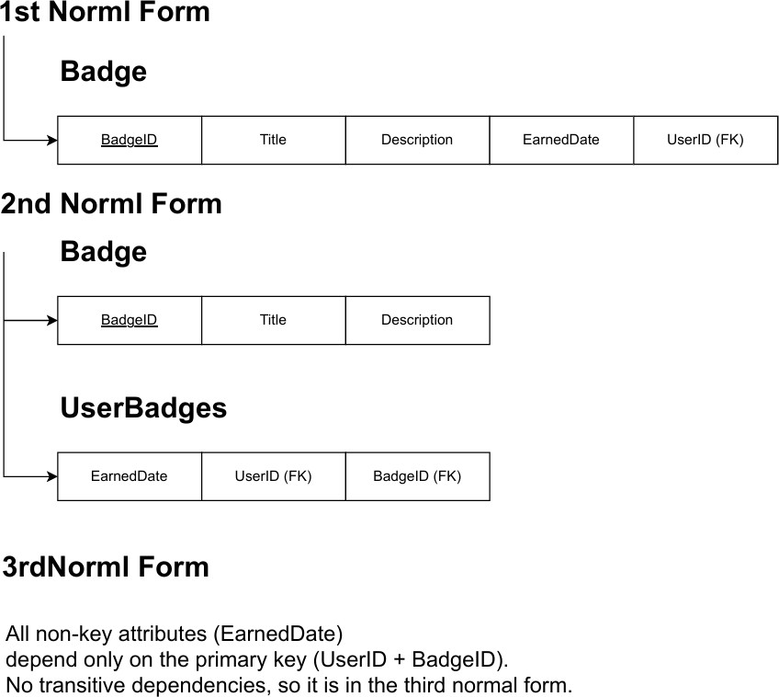

Logical Database Design
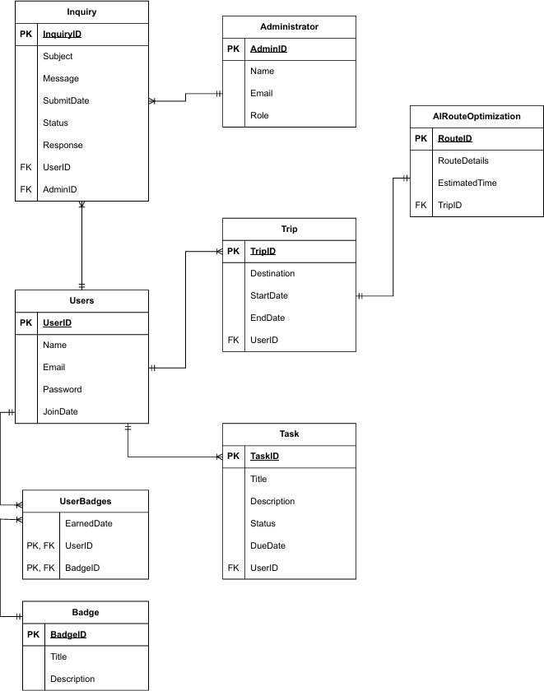

Physical Database Design
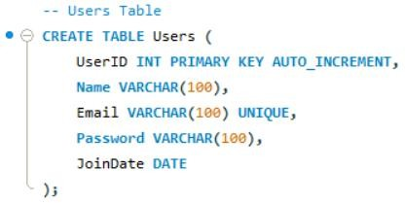
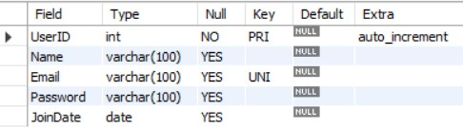
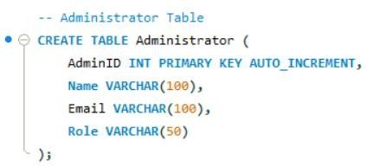
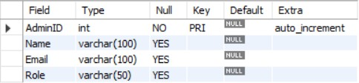

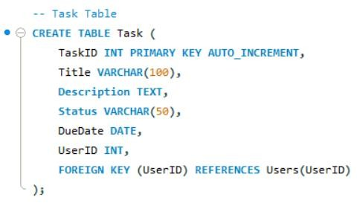
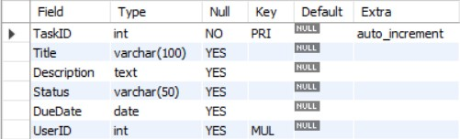
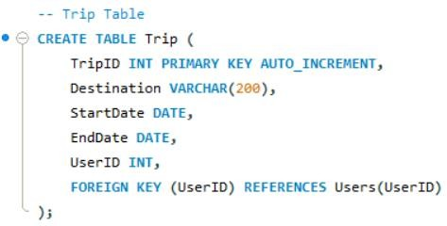
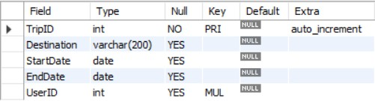

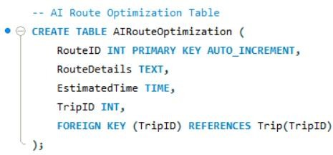
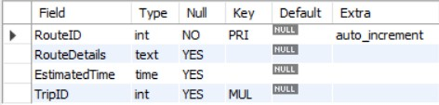
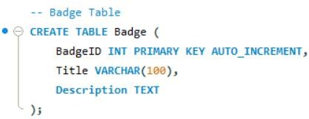
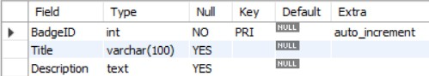

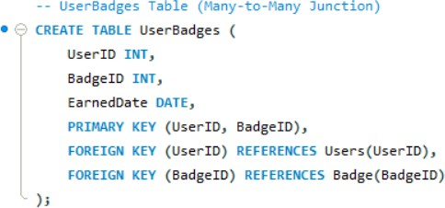
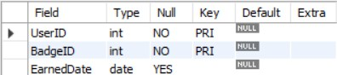
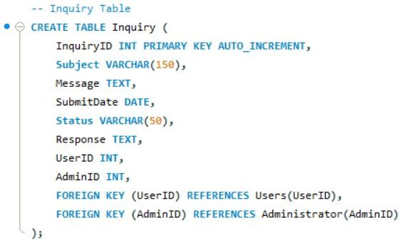
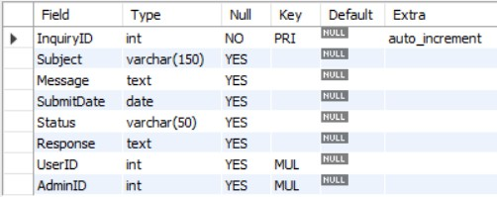

DEVELOPMENT

Overview
This chapter presents the key design and implementation elements that form the foundation of the system. It outlines the tools and technologies selected to support development, describes the navigation structure that guides user interaction, and explains the user interface design principles adopted to ensure a clear and intuitive experience. Additionally, this chapter shows the approach to database connectivity, which enables communication between the application and its data resources.

Tools/ technologies selected for implementation

Navigation design
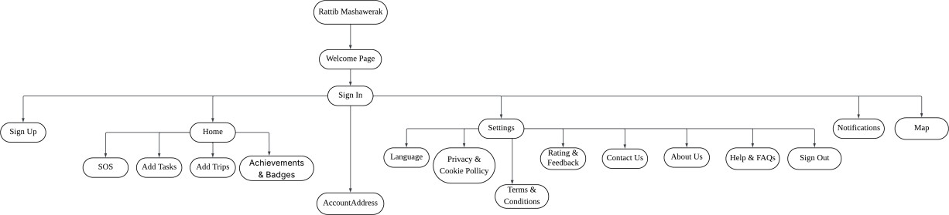

Main Entry - Rattib Mashawerak
The main entry point and title of the application. Serves as the launching interface where
users are introduced to the app’s purpose and directed to the Welcome Page.

Welcome Page
The landing screen displayed upon opening the app. It introduces the platform and offers two primary options after tabbing on the Let’s Get Started button: Sign In for existing users and Sign Up for new users.

Authentication Phase - Sign In / Sign Up
The authentication process where users either log in to their existing accounts or create new ones. Successful authentication leads to the Home Page (main dashboard).

Home
The central hub of the app, displaying the main features and tools. Users can access personal tasks, trips, achievements, or quick SOS help from here.

Home Subsections
SOS: A quick-access emergency feature allowing users to send alerts or request help during travel or critical situations. This feature can be used during the initial registration period, and it is optional; not all users are required to use it.
It can be activated by pressing on the SOS button. A window will be displayed, and the user can
add family or friends’ numbers to use it in the future or can cancel and add them later.
Add Tasks: Enable users to create, edit, or delete their daily or trip-related tasks. Supports reminders or checklist functions.
Add Trips: Allows users to create, edit, or delete trip details such as locations, destinations, dates, and notes.
Achievements & Badges: Displays earned milestones and motivational badges based on completed activities, encouraging consistent engagement.

Notifications
A dedicated area showing recent updates, reminders, messages, and alerts relevant to the
user’s activities.

Settings
The configuration area is where users can edit settings based on their preferences, and access support or legal information.

Settings Subsections
Language: Let users select their preferred display language for the app’s interface.
Privacy & Cookie Policy: Provides transparency on how user data is collected, stored, and used, along with cookie management details.
Terms & Conditions: Outlines the legal rules, obligations, and rights governing the use of the app.

Rating & Feedback: A form or link where users can share opinions, rate the app, or suggest improvements.
Contact Us: Contains channels (email, phone, or chat) for users to reach customer support or the app team.
About Us: Describes the app’s mission, vision, objective, and the team or organization
behind it.
Help & FAQs: Offers troubleshooting guidance, frequently asked questions, and user tips.
Sign Out: Logs the user out of their account, ending the session securely.

User interface design

Database connectivity

TESTING AND CONVERSION

Overview
This chapter outlines the testing process used to evaluate the system’s functionality and reliability. It begins with the test plan, which defines the testing objectives and methods. Unit testing verifies individual components, while integration testing checks how combined modules interact. Finally, system testing evaluates the complete system to confirm that all features work correctly and meet specified requirements.

Test plan

Unit testing

Integration testing

System testing

SYSTEM DOCUMENTATION

Overview
This section provides a comprehensive description of the system documentation, support materials, and assistance resources. These materials aim to help users, system administrators, technical teams, and new learners how to interact with the system smoothly, solve issues quickly, and maintain long-term operational efficiency. The subsections below show the user manual, technical support manual, and the online help and FAQs resources in detail.

User manual
Firstly, download the app from the store.
After the welcome page you can tab on Let’s Get Started button

Sign up
- If you do not have an account, click on Sign up.
- Enter your first name.
- Enter your second name.
- Enter your Email.
- Enter your password.
- Enter your phone number.
- Click on Sign up.
- Or you can sign with your Google account, Apple account or Facebook account.

Sign in:
- Enter your username or email.
- Enter your password.

Sign out:
- Click on the settings button on the left top of the screen.
- Click on log out.

Password recovery:
- Select“ Forgot password".
- Enter your Email.
- Create new password by following these conditions:
  - At least 8 characters long but 10 characters or more is better.
  - A mix of uppercase and lowercase letters, numbers, and symbols.

  - There is no word in the dictionary or name of a person, character, product or organization.
  - It is significantly different from previous passwords.
  - It's easy for you to remember but hard for others to guess.

Add Tasks:
- Go home.
- Click on “Add Tasks”.
- Select the task date.
- Select the task type.
- Write down the task.
- Click “Add”.

Add Trips:
- Go home.
- Click on “Add Trips”.
- Check the location in the map.
- Write down the trips.
- Click “Add”.

Achievements and Badges:
- Go home.
- Click on “Badge”
- After you complete a specific percentage of your daily tasks, you will receive a badge as a reward.
- Each badge represents your achievements, shown in your profile page.
- You can see your achievements and badges with friends to motivate them.

Map:
- Go to map.
- Search location.
- Add it as a trip.

Search:
- You can search about tasks.
- You can search about trip.
- You can search about place.

Language:

- Click on settings button on the left top of the screen.
- Click on “Language”.
- Choose your preferred language.
- Click “Ok”.

Privacy & Cookie Policy:
- Click on settings button on the left top of the screen.
- Choose the button you need from the options
- “My profile “: Your personal data such as name, email, phone number are securely
stored. (never shared with others)
- “Cookies “used to improve your app experience through saving your preferences and login sessions.
- Also, you able to manage your cookie preferences in the settings.
- We follow strict security measures to protect your information.

Terms & Conditions:
- Click on settings button on the left top of the screen.
- click on Terms & Conditions.

Rating & Feedback:
- Click on settings button on the left top of the screen.
- Click on “Rate & Feedback”.
- Select the number of stars of your satisfaction with the app.
- Write your feedback or suggestions.
- Click on “Submit”.
- Your feedback helps us improve the app and provide better service.

Contact Us:
- Go to “Settings”.
- Click on “Contact Us”.
- You can send your question, or problem through the contact form, or email us directly at support@rattibmashawerak.com.
- Our support team will reply to you as soon as possible.
- Moreover, you can find commonly asked questions that may help you.

About Us:
- Click on settings button on the left top of the screen.
- Rattib Mashawerak” is a smart application task and trip planner that helps users organize
their daily schedules based on their location and time.

- Our goal is to save your time and effort by suggesting the shortest and most efficient routes.
- We believe in productivity, simplicity, and innovation to make your daily life easier.
- Developed by a dedicated MIS team from King Faisal University.

Technical support manuals

Online Help and FAQs
- Who are we?
RATTIB MASHAWERAK is a smart application that helps you organize your daily trips smoothly and easily, from the starting point to the arrival point. With the aim of completing trips in record time. The application facilitates the traffic plan based on the priority and proximity of places, considering store closing times, and reducing traffic congestion by providing smart paths that facilitate the movement process.

How can I register in the Rattib Mashawerak?
To register for the Rattib Mashawerak, you must first download the application from one of the available platforms such as (Apple Store, Google Play). After the download is complete, you can easily create a new account by entering (name, email, password). Or register directly via (Google, Apple, Facebook.

How does the Rattib Mashawerak application work?
The Rattib Mashawerak application analyzes the user's itinerary using geographic information systems technology, where it identifies the entered locations and analyzes the distances and time between them. Then the application suggests an organized itinerary based on the proximity of geographical locations, store closing times, and the extent of traffic congestion, in order to complete the trips easily and conveniently, saving time and effort for the user and making his movement more efficient and smoother.

Is the application limited only to arranging trips?

No, the Rattib Mashawerak application is not limited only to organizing trips but also includes organizing daily tasks through the (Add Tasks) box. Which helps manage tasks related to trips in addition to personal tasks. The application becomes a comprehensive tool to facilitate the organization of time and effort.

Is the Rattib Mashawerak app safe?
Yes, the Rattib Mashawerak application is completely secure. We are keen to protect the user's privacy and not share personal data or information about the current site with us or any third party. Only in-app information is used to provide unique and secure experience.

Does the Rattib Mashawerak application require an Internet connection?
Yes, the Rattib Mashawerak application requires an Internet connection to make the trip more accurate, by updating location data and maps instantly and automatically. To provide accurate and smooth experience.

What is the SOS button? What is the purpose of it?
The SOS field is a field designed for emergency situations, allowing the user to send an immediate notification of his current location to the contact registered within the application, which could be (a family member – friends). Its purpose is to ensure user safety within the framework of traffic safety and to help avoid accidents or dangerous situations during transportation.

Who does the SOS field serve? How can it be activated?
The SOS box serves users who suffer from chronic diseases (heart disease - diabetes – high blood pressure – asthma - epilepsy - or panic attacks) and other conditions that may affect the user's safety during his trip. It is activated through the application settings by filling in the contact information and numbers of the people who can reach them in emergency situations.

What does the Rattib Mashawerak app aim for?
The Rattib Mashawerak application aims to achieve several goals, including saving time and effort for the user, reducing traffic congestion, raising the level of achievement and productivity, in addition to reducing costs by reducing fuel consumption for the individual.

How can the Rattib Mashawerak app be useful for tourists?
The Rattib Mashawerak app helps tourists and travelers organize their trips within the city, allowing them to easily add the entertainment or historical places they want to visit and schedule them based on their locations.

Does the app support alerts or reminders for trips?
Yes, the Rattib Mashawerak app has an alert mechanism, reminding the user in multiple situations such as forgetting a trip, the approaching store closing time, or the remaining time to complete the trip.

Is it possible to modify the trips?
Yes, the Rattib Mashawerak app allows the user to edit, delete, or add trips within their itinerary

Is it possible to use the application without creating an account?
Yes, creating an account benefits you with the services and features provided by the application, saves progress, and activates the notifications.

Does the app work in all cities?
Yes, the Ratib Mashawerak app works in all cities and uses a system (GIS) to determine which locations you will go to.

Is Rattib Mashawerak available in multiple languages?
Yes, the Rattib Mashawerak app is available in several languages to make the experience easier for users from different countries.

What are the achievements and badges? What do they aim for?
The achievements and badges button in the Ratib Mashawerak application aims to motivate the user and encourage him to complete his trips and tasks to the fullest. By completing tasks and errands, the user receives points that enable him to receive medals as a symbolic reward for his achievement, which creates an enjoyable experience and increases his motivation to achieve more productivity and discipline in his daily life

How can I contact Rattib Mashawerak customer service?

You can contact the customer service team via the “Contact Us” box in settings within the application, where you can submit your inquiry or problem and you will be answered as soon as possible. The application also allows communication via dedicated technical support email, to ensure that any problem facing the user is resolved as quickly and professionally as possible.

- REFERENCES

